SpaceX AI

# Abstract

SpaceX AI is an innovative project that combines artificial intelligence (AI) technology with the world of memes. This project aims to create a new blockchain-based platform that allows users to generate space-related memes with the help of AI technology. The platform will be built on top of a public blockchain, allowing users to create, share, and monetize space-themed memes in a decentralized and secure environment. With SpaceX AI, we aim to create a new ecosystem for space enthusiasts to come together and engage with each other through humor and creativity.

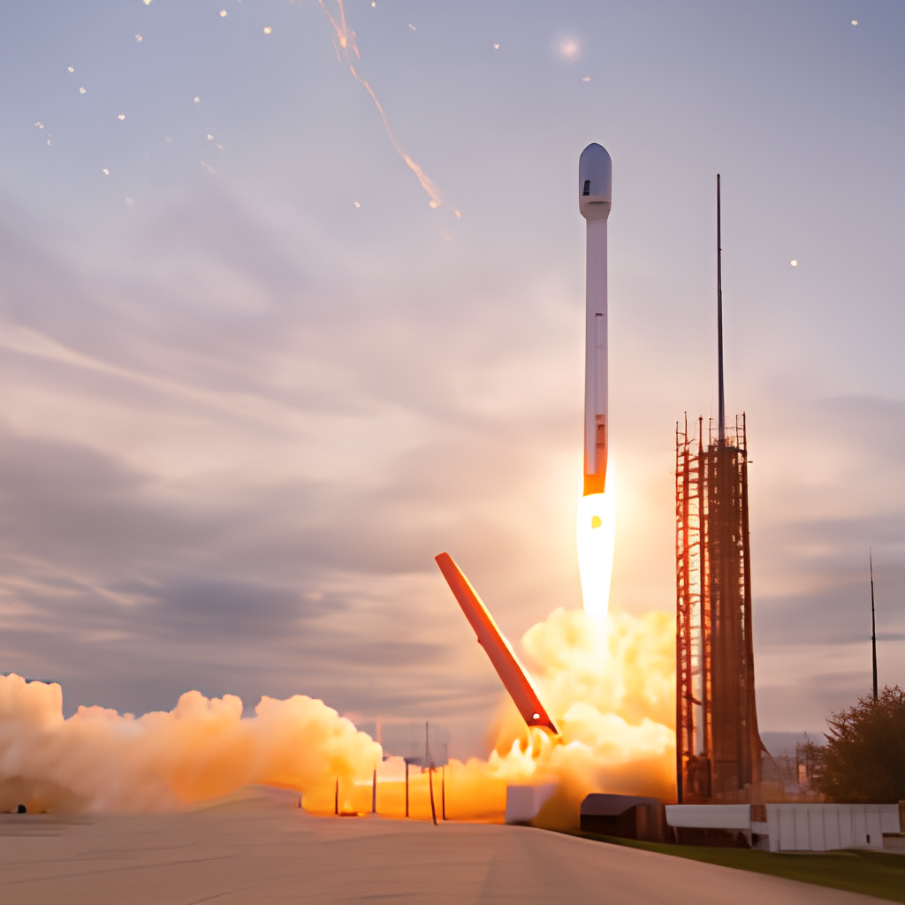

# Introduction

The meme industry has been growing rapidly in recent years, and memes have become a crucial part of online culture. At the same time, space exploration has also been gaining momentum, with companies like SpaceX leading the charge. With SpaceX AI, we aim to bring these two worlds together by creating a platform that allows users to generate space-themed memes with the help of AI technology.

# SpaceX AI

SpaceX AI is a blockchain-based platform that utilizes AI technology to generate space-related memes. The platform will consist of several key components:

1. AI-powered meme generator: The SpaceX AI platform will feature an AI-powered meme generator that will allow users to easily create space-related memes without any specialized skills. The generator will use deep learning algorithms to analyze space-related images, text, and other content to generate memes that are funny, relatable, and shareable.
2. Decentralized marketplace: The SpaceX AI platform will provide a decentralized marketplace for meme creators to sell their creations to users and curators. Creators will set their own prices and receive payment directly from buyers through smart contracts.
3. Community curation: The SpaceX AI platform will have a community-based curation system that will allow users to vote on and curate the best space-related memes. This will help ensure that high-quality memes rise to the top and gain visibility.
4. Token economy: The SpaceX AI platform will use a token economy to incentivize users to create and curate space-related memes (create to earn). Users who create high-quality memes and curate popular content will earn tokens, which can be used to access premium features or to purchase other memes.
5. Launchpad: The SpaceX AI will make available a safe launchpad that will support the launching of other similar AI projects.

# Benefits of SpaceX AI

1. Decentralization: SpaceX AI provides a decentralized ecosystem for space-themed meme creation and distribution, ensuring that no single entity controls the market.
2. Empowerment of creators: The SpaceX AI platform empowers creators by providing a direct means of monetization and enabling them to set their own prices.
3. Quality control: The community-based curation system helps ensure that only high-quality space-related memes gain visibility, reducing the prevalence of low-quality, spammy content.
4. AI-generated content: The AI-powered meme generator provides users with an easy way to create engaging and shareable space-related memes without any specialized skills.
5. Token economy: The SpaceX AI platform incentivizes users to create and curate high-quality space-related content through a token economy, providing an additional means of earning revenue.
6. GPT-4 Introduction (test)

# Conclusion

SpaceX AI is a unique project that combines the world of memes with the excitement of space exploration. With this platform, we aim to create a new ecosystem for space enthusiasts to come together and engage with each other through humor and creativity. By leveraging advanced AI technology and blockchain-based infrastructure, we hope to create a secure and decentralized environment for users to create, share, and monetize space-related memes. With SpaceX AI, we aim to bring a new level of fun and excitement to the world of space exploration.